**Recycling problem**

*Management Report*

In order to minimize the processing and purchasing costs of the recyclable materials, we determined the optimal mix of which materials to use based on the demand and availability requirements.

Requirements included a demand of 500 tons of newsprint, 600 tons of packaging, and 300 tons of print stock. The available recycled materials were limited to 600 tons of newspaper, 500 tons of mixed paper, 300 tons of white office paper, and 400 tons of cardboard.

Constraints to the optimization problem required the materials used to remain within the available amount while meeting the product demand. The yield percentages of recycled material to resultant products must be included, as the production process yields lost or unusable material. Finally, it is important to note that all variables used in this calculation must be positive to prevent inaccurate results based on unrealistic production variables. Figure A shows the application of the constraints in Lindo to produce optimal production values.

From our findings, we determined that the optimal mix is to use:

* 588.24 tons of newspaper to make the required 500 tons of newsprint
* 11.76 tons of newspaper, 71.43 tons of mixed paper, 300 tons of white office paper and 397.78 tons of cardboard to make the required 600 tons of packaging
* 428.57 tons of mixed paper ro make the required 300 tons of print stock

This allocation of resources ensures a gross profit of $44,067.74. Figure B shows the output used to determine the optimal mixes, while Figure C briefly summarizes the proof of each constraint being met.

*Figure A: Objective Function and Constraint Inputs in Lindo*

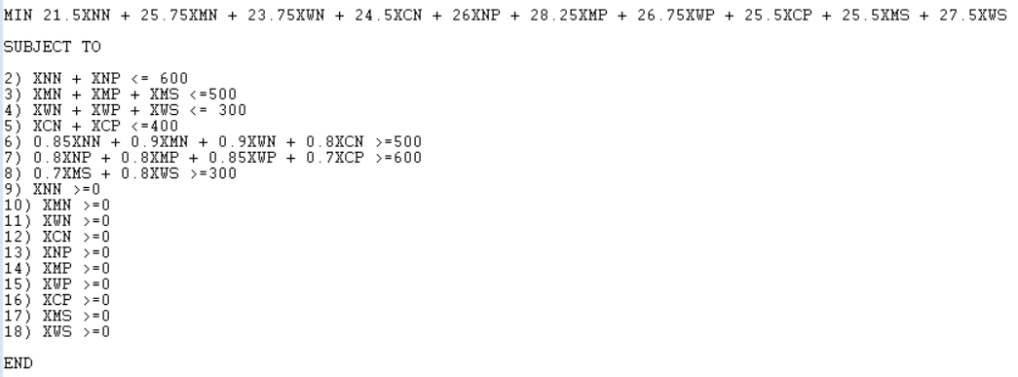

MIN 21.5XNN + 25.75XMN + 23.75XWN + 24.5XCN + 26XNP + 28.25XMP + 26.75XWP + 25.5XCP + 25.5XMS + 27.5XWS

SUBJECT TO

XNN + XNP <= 600

XMN + XMP + XMS <=500

XWN + XWP + XWS <= 300

XCN + XCP <=400

0.85XNN + 0.9XMN + 0.9XWN + 0.8XCN >=500

0.8XNP + 0.8XMP + 0.85XWP + 0.7XCP >=600

0.7XMS + 0.8XWS >=300

XNN >=0

XMN >=0

XWN >=0

XCN >=0

XNP >=0

XMP >=0

XWP >=0

XCP >=0

XMS >=0

XWS >=0

END

*Figure B: Lindo Output Showing Optimal Production Values to Minimize Cost*

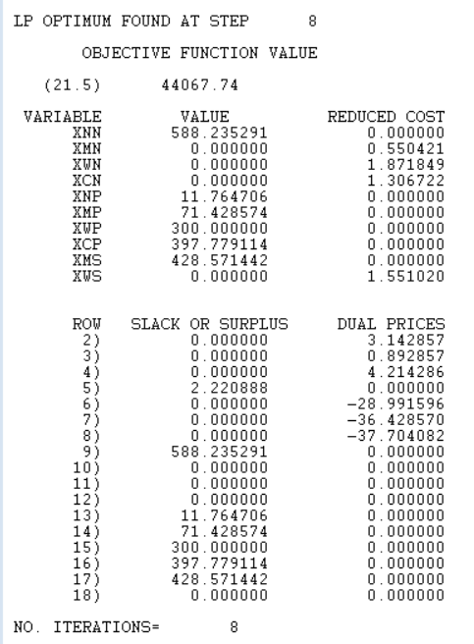

*Figure C: Proof Table Showing how Each Constraint is Met*

| Constraint | Proof of constraint being followed |
| --- | --- |
| All variables being greater than zero | Figure B shows all variable values being zero or greater |
| XNN + XNP <= 600 | (588.24)+(11.76)<= 600  600 <= 600 |
| XMN + XMP + XMS <=500 | (0)+(71.43)+(428.57)<=500  500 <= 500 |
| XWN + XWP + XWS <= 300 | (0)+(300)+(0)<=300  300 <= 300 |
| XCN + XCP <=400 | (0)+(397.78)<=400  397.78 <= 400 |
| 0.85XNN + 0.9XMN + 0.9XWN + 0.8XCN >=500 | 0.85(588.24) + 0.9(0) + 0.9(0) + 0.8(0) >=500  500 >= 500 |
| 0.8XNP + 0.8XMP + 0.85XWP + 0.7XCP >=600 | 0.8(11.76) + 0.8(71.43) + 0.85(300) + 0.7(397.78) >=600  600 >= 600 |
| 0.7XMS + 0.8XWS >=300 | 0.7(428.57) + 0.8(0) >=300  300 >= 300 |